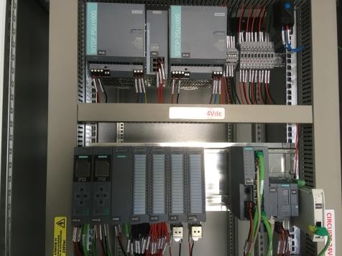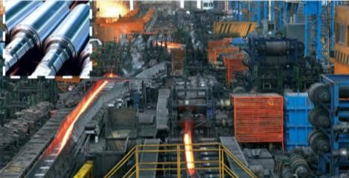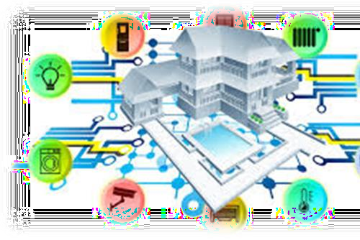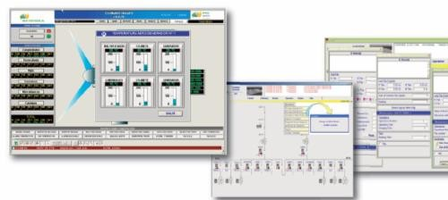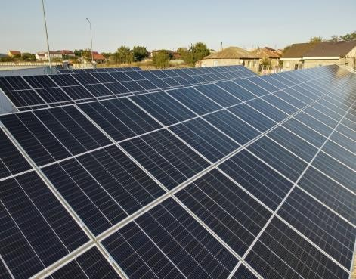

SIS SA
Expressions of interest

KEYWORDS: Microgrid, Smart control, Digital Twin, Energy efficiency

LOOKING FOR
- Coordinators
- Partners
- Case studies

CONTACT INFORMATION
- Research Engineer

Teodora.mindra@sis.ro

Company description

SIS has a strong expertise in innovative industrial automation methods and tools, resulted in over 35 national and European research projects. A relevant result from these projects is a data-logger for increasing building energy efficiency using both structural and real time data analysis. Our main competencies cover the following areas: process data acquisition and control (including design and implementation of Building Management Systems, green buildings, renewable energy plants and water management systems), industrial process interfaces and communication protocols, real time data analysis, refinery burner optimization, advanced intelligent methods for wastewater management.

Projects are expected to contribute to the following outcomes:

- Support objectives of the European Green Deal and of the EU SME Strategy for a sustainable and digital Europe;
- Increased resilience of SMEs, by fostering technological and social innovation in SMEs to support their transition to more sustainable business models and more resource-efficient and circular processes and infrastructures;
- Increased competitive sustainability of SMEs through the uptake of advanced technologies;
- Stronger innovation support ecosystems supporting the green, social and economic transition of SMEs, by leveraging synergies between existing EU networks and SME support initiatives.

